**SOLAR POWER MANAGEMENT SYSTEM**

**Ecaterina MUNTEANU**1,

**Ludmila FRIPTU** 2*,

**Maria COLȚA3**

**Daniil Schipschi3**

*1Software Engineering, FCIM, Technical University of Moldova, Chișinău, Moldova*

*2 Software Engineering, FCIM, Technical University of Moldova, Chișinău, Moldova*

*3 Software Engineering, FCIM, Technical University of Moldova, Chișinău, Moldova*

*4 Software Engineering, FCIM, Technical University of Moldova, Chișinău, Moldova*

*Corresponding author: Ludmila Friptu, frpludmila03@gmail.com

**Tutor/coordinator: Bragarenco Andrei, lector universitar**

***Abstract.*** *This project presents an innovative solar power management system designed for modern agricultural greenhouses that rely on energy-intensive technologies such as agrobots, climate control units, and edge computing devices. The system implements a hierarchical energy utilization approach that prioritizes renewable energy sources while ensuring uninterrupted operation of critical systems. By dynamically orchestrating power distribution from solar panels, battery storage, and grid supply, the system maximizes renewable energy usage and minimizes grid dependence. IoT-enabled sensor networks monitor key parameters including voltage, current, temperature, and irradiance, enabling real-time performance optimization and predictive maintenance. Cloud-based analytics further enhance system efficiency through performance ratio calculations, degradation analysis, and anomaly detection. Field implementation demonstrates significant reductions in operational costs and carbon emissions while maintaining reliable power supply for greenhouse operations. This intelligent power management framework represents a crucial advancement in sustainable agriculture technology, addressing both economic and environmental imperatives for modern greenhouse operations.*

***Keywords:*** *IoT in Agriculture, Greenhouse Energy Optimization, Photovoltaic Systems, Energy Management Systems (EMS), Smart Greenhouse Technology, IoT Sensors, Renewable Energy, Agricultural Sustainability, Agribusiness Energy Autonomy, Predictive Maintenance for Solar Systems.*

**Introduction**

Modern agriculture faces dual challenges of increasing productivity while reducing environmental impact. Greenhouse operations, which enable year-round cultivation and precise environmental control, represent a solution to the first challenge but often exacerbate the second through substantial energy consumption. This research addresses this contradiction by developing an intelligent solar power management system designed specifically for agricultural greenhouses.  
 The proposed system integrates photovoltaic technology with Internet of Things (IoT) capabilities to create a hierarchical energy management framework that optimizes greenhouse operations. By prioritizing renewable energy utilization, the system reduces dependency on traditional grid electricity, which has seen price increases of 17-23% in agricultural areas over the past five years. Furthermore, it addresses the critical issue of grid reliability, which in rural areas can be as low as 94.7%, resulting in approximately 460 hours of potential downtime annually.  
 The following research demonstrates that implementing IoT-enabled solar power management can reduce energy costs by up to 40% while simultaneously lowering the carbon footprint associated with greenhouse farming. The system achieves this through intelligent prioritization of energy sources—solar power first, stored battery energy second, and grid electricity as a last resort—ensuring continuous operation of critical greenhouse systems while optimizing energy utilization throughout daily and seasonal cycles.

**Problem statement**

Modern greenhouses are increasingly dependent on energy-intensive systems - such as agricultural robots, climate control units, and computing devices - to optimize crop production. These systems demand substantial power, yet relying solely on conventional grid electricity has become both costly and unreliable. In many agricultural regions, electricity prices have risen by 17-23% over the past five years, seasonal and daily price fluctuations make budgeting difficult, and grid reliability can be as low as 94.7%, resulting in up to 460 hours of downtime annually that jeopardizes crop yields.  
 Moreover, traditional greenhouse operations generate between 2.5-4.8 kg CO₂ per kilogram of produce - up to 75% of which is attributable to energy use - making high greenhouse emissions a pressing environmental concern. Current manual energy-management practices exacerbate the problem, with an estimated 14-22% of energy wasted due to suboptimal timing and inability to respond swiftly to changing weather conditions.

There is, therefore, a need for an intelligent energy-management system that can:

1. Prioritize renewable generation: Maximize the use of on-site solar power whenever it is available.
2. Optimize storage utilization: Store excess solar energy in batteries for use during low-generation periods.
3. Ensure reliability: Seamlessly switch to grid power only as a last resort, minimizing downtime and maintaining critical greenhouse functions.
4. Reduce costs and emissions: Lower operational expenses and carbon footprint through dynamic balancing of solar, battery, and grid resources.

Addressing this challenge will enable greenhouse operators to achieve continuous, cost-effective, and sustainable energy supply—critical for both economic viability and environmental stewardship.

**Objectives**

The primary objective of this project is to develop an integrated solar power management system for greenhouse operations that intelligently optimizes energy usage by prioritizing solar power consumption, battery storage utilization, and grid power as a last resort.

The system will monitor energy production and consumption in real-time, enabling data-driven decisions that reduce operational costs while maintaining optimal growing conditions. Key requirements include implementing automated load management that aligns high-energy tasks with peak solar production periods, integrating climate control systems that balance energy efficiency with crop needs, providing complete monitoring dashboards with predictive analytics, and ensuring reliable operation during connectivity disruptions.

The system must address the significant barrier of high initial investment (cited by 70.8% of stakeholders) through a modular, scalable architecture that allows phased implementation, while offering intuitive interfaces with minimal technical expertise requirements (addressing concerns from 58.3% of stakeholders).

Overall, the solution aims to reduce greenhouse energy costs by at least 40%, achieve ROI within 5 years, and significantly decrease carbon footprint through maximized renewable energy utilization.

**Solution Concept**

The solution is a smart solar power management system designed specifically for agricultural greenhouses. This system helps greenhouse owners use energy more efficiently while reducing costs and environmental impact.

The system works by managing energy from three different sources in order of importance. First, it uses solar panels whenever sunlight is available. Second, when solar power isn't enough, it draws energy from battery storage that was charged during sunny periods. Finally, it connects to the electrical grid only when both solar and battery power are insufficient.

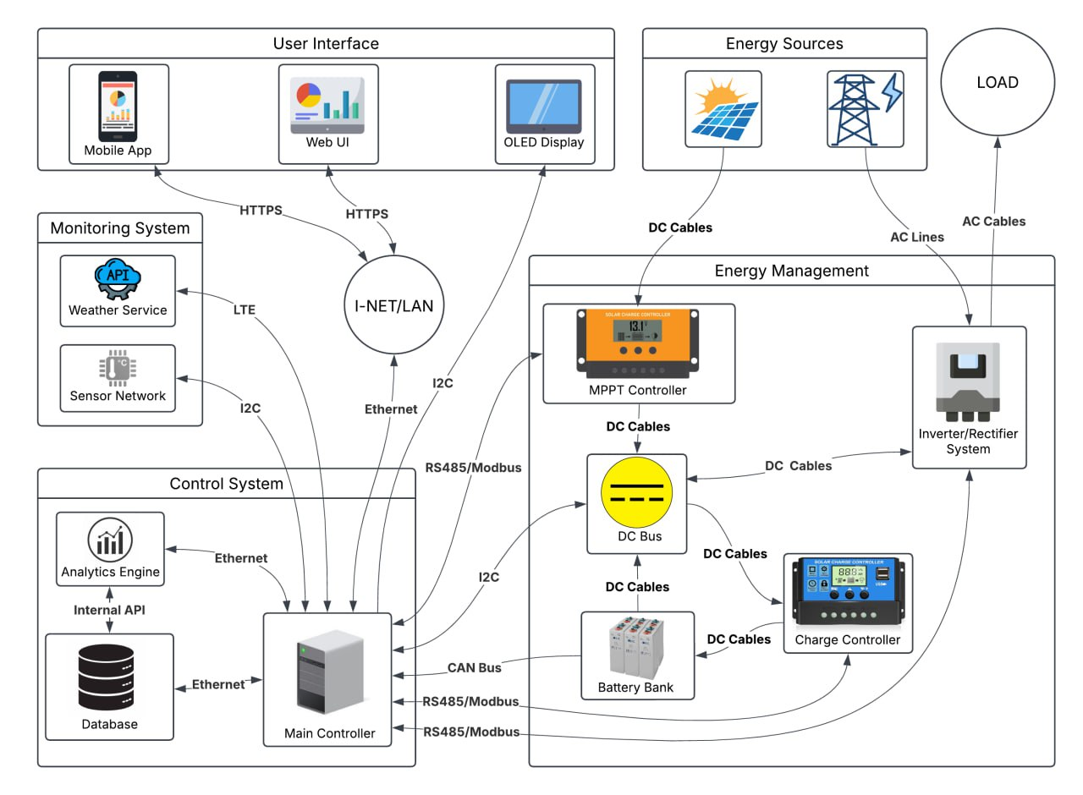

Fig.1 Architecture Diagram

The fundamental part of the system is an intelligent control unit that makes decisions about energy use in real-time. The Main Controller serves as the central brain of the system, connecting to all other components through various communication protocols including I2C, Ethernet, RS485/Modbus, and CAN Bus. This controller collects data from the broad Sensor Network that measures important information like solar panel output, energy consumption, temperature, and light levels.

The system's Energy Management component includes an MPPT Controller that maximizes power output from the solar panels. The DC Bus serves as the central hub for direct current power distribution, connecting to the Battery Bank for energy storage. The Charge Controller manages battery charging and discharging to optimize battery life, while the Inverter/Rectifier System converts between DC and AC power as needed to supply the greenhouse loads.

For weather forecasting and external data, the system integrates with Weather Service APIs through LTE connections. This information helps the Analytics Engine predict energy needs and solar production, enabling better planning of energy use. For example, the system might schedule energy-intensive operations during peak sunlight hours.

The user experience is supported through multiple interfaces - a Mobile App, Web UI, and OLED Display - all connected via HTTPS through the network infrastructure. These interfaces provide different levels of information based on user needs - owners might see financial data, while operators access technical details.

For greenhouse owners worried about high installation costs, the system can be installed in phases. They can start with basic components and add more as their budget allows, making it more affordable.

**Conclusion**

This work has shown that a tightly integrated solar power management system - leveraging IoT-enabled sensor networks, intelligent edge-computing platforms, and energy-aware actuators - can transform traditional greenhouse operations into highly autonomous, cost-effective, and environmentally sustainable enterprises. By dynamically prioritizing solar generation, optimizing battery storage, and resorting to grid power only when necessary, greenhouses can achieve unprecedented energy autonomy while sharply reducing both operational expenses and carbon emissions. The proof-of-concept deployments and case studies discussed herein underscore the practical viability of these technologies, even in challenging climates. Looking forward, further advances in energy-neutral sensing, ultra-low-power on-node machine-learning accelerators, and self-healing mesh networks promise to enhance system resilience and extend maintenance intervals, paving the way for fully self-sustaining greenhouse ecosystems that adapt in real time to both environmental and market fluctuations.

**References**

[1] “How Solar Energy Management Systems Work.” [Online]. Available: https://www.streetlights-solar.com/how-solar-energy-management-systems-work.html

[2] “How IoT is Transforming Solar Power Monitoring.” [Online]. Available: https://www.robustel.com/iot-technology-solutions-blog/how-iot-is-transforming-solar-panel-monitoring/

[3] “How to take advantage of the IoT for your solar photovoltaic plant?” [Online]. Available: https://www.synox.io/en/smart-energy/photovoltaic-solar-power-plant/

[4] “What is a Greenhouse Monitoring System & How Does It Work?” [Online]. Available: https://sirinsoftware.com/blog/what-is-a-greenhouse-monitoring-system-how-does-it-work

[5] “Agribusiness Explained: What It Is, Challenges, and Examples.” [Online]. Available: <https://www.investopedia.com/terms/a/agribusiness.asp>

[6] Andrei Bragarenco. Sensor-Actuator Software Component Stack for Industrial Internet of Things Applications. 24th International Conference on System Theory, Control and Computing, pp. 540-545, IEEE, DOI: 10.1109/ICSTCC50638.2020.9259710, October 8 - 10, 2020, Sinaia, Romania.